Linux-01 Video Task

- Pwd =show current directory working
example output
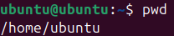

- cd=changes directory to india
example output
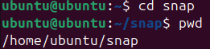

- cd .. = goes one step back to the previous directory
example output
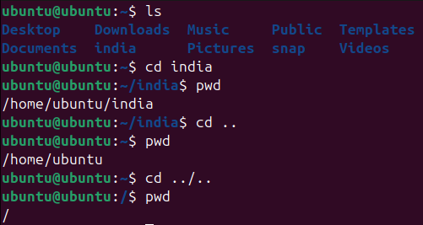

- mkdir india = creates a new directory (folder) named “india ”
example output

- ls = list all files and folder in the currect directory example output
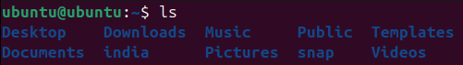

- ls –a = list all file including hidden ones those starting with .)
example output
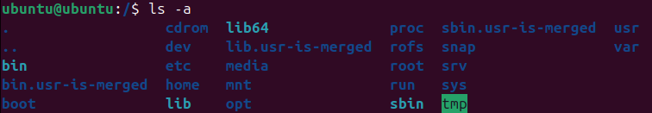

- ls -l = show a details list (permission,owner,size,date)
example output
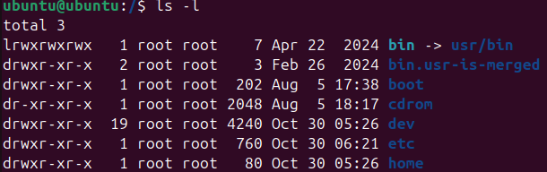

- ls –ls = show file with their sizes in detail
example output
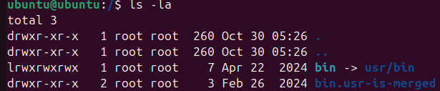

- ls –la = shown hidden files with details information
example output

- ls –ltr =lists files in detailed format, sorted by time (oldest first)
example output
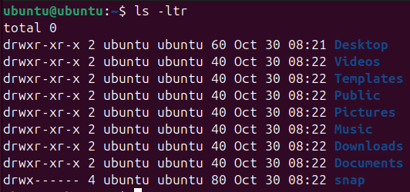

- touch= create an file name horizon
example output
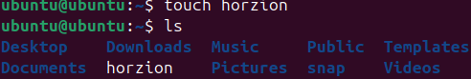

- mv horizon .horzion/Documents
example output
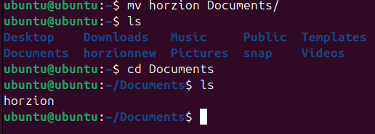
- vi tech = open tech file in vi editior to edit text inside horizonnew
example output
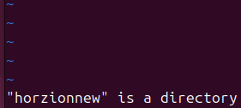

- cat tech = Display content of a file
example output
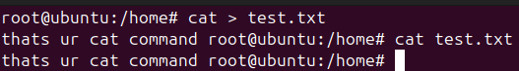

- rm filename = delete a file
example output
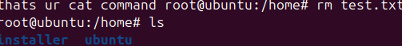

16= deletes a dircotory (folder) and all file inside it
Example output
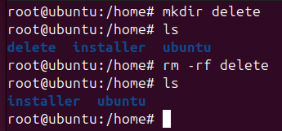

Thanks you

